# What is Network ?

Is Proper communication

# Type Of Networks

|  |  |  |  |  |
| --- | --- | --- | --- | --- |
| ***Name*** | ***Full Name*** | ***Range*** | ***Wired ?*** | ***Ex..*** |
| **PAN** | **Personal Area Network** | **10 ft to 15 ft** | **No** | **Bluetooth** |
| **HAN** | **Home Area Network** | **50mtr to 60 mtr** | **No** | **Wi-Fi , Hotspot** |
| **LAN** | **Local Area Network** | **Max 100 mtr** | **Yes** | **Office Room** |
| **CAN** | **Campus Area Network** | **500 mtr to 600mtr** | **Yes** | **Collage Network** |
| **WAN** | **Wide Area Network** | **More than 1 km** | **Yes** | **Compani Two Brach connection** |
| **WLAN** | **Wireless Local Area Network** |  | **No** |  |
| **VPN** | **Virtual Privet Network** |  |  |  |
| **SDN** | **Software Define Network** |  |  |  |

* **Minimum Requirement For Network ?**
  + **Hardware**
    - 2 End Devices
    - NIC Card /LAN Port /Ethernet Port
    - Transmission Media
  + **Softwere**
    - OS (Operating System)
    - NIC Driver

Topology

BUS Topology

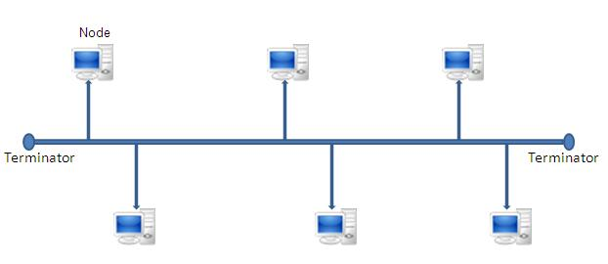

* **Control Protocols**
  + - CSMA = “Carrier Sense Multiple Access”
    - CSMA-CD=” Carrier Sense Multiple Access and Collusion Detection
    - CSMA-CA=” Carrier Sense Multiple Access Collusion Avoidance”
* **Advantages**
  + - Easy To Install
    - Low Implementing cost
* **Disadvantages**
  + - Low Speed (10 mb/s)
    - Collusion Between Two Signal

Ring Topology

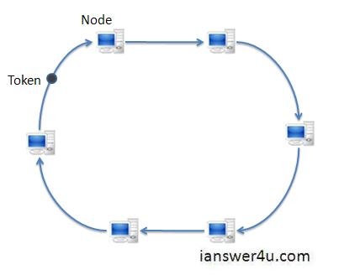

* **A ring network is a network topology is which each node connect to exactly tow other nodes . Forming a single continuous pathway for signals through each node . a ring data travels from node to node . with each node along the way handing every packet .**

**Its Use “Token Ring “ Technology .**

* **Technology**
  + **TRT = “**Token Rotation Time”
  + Token Holding Time = 2 x **TRT**
* **Advantages**
  + - No Collusion
* **Disadvantages**
  + - When any Devices or Connections is Failed, Total network goes down
    - Implementing cost more than bus topology
    - Less speed (max 10 mb/s) {because of Backbone CO-Axial Cable}
    - Moving devices is problematics

Dual Ring Topology

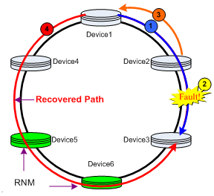

* **Dual Ring topology is a network redundant where nodes are connected using two consenting ring with four branche . Dual ring topology is ideal for application with cabling issues or small network that are not frequently reconfigure .**
* **Advantages**
  + - Speed and Reliability
    - Uninterrupted long distance communication
    - Terminator are not Required
* **Disadvantages**
  + - Network issues from bad ports,
    - Negative network impact from any added Altered or damaged device
    - More cabling cost

**Star Topology**

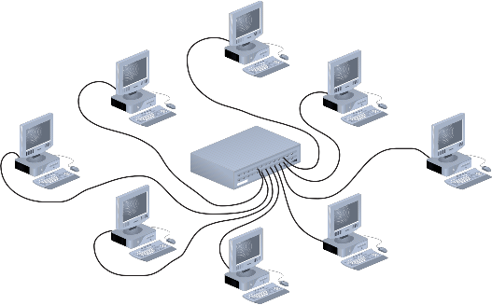

* **A star topology is a topology for a LAN in which all nodes are individually connected to a central Connecting Point , like “Hub” or “Switch”**
* **Advantages**
  + - Easy to Install
    - Easy to maintains
    - Faster Data Transfer Rate (100 mb/s)
* **Disadvantages**
  + - Required more cable than Bus
    - If the connecting Device failed , then total network Failed .

Mesh Topology

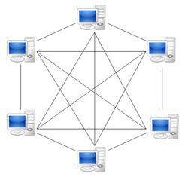

* **Mesh topology is a type of networking whare all nodes cooperate to distribute data among each other**
* “Cable Need”= n(n-1)/2
* “Port Need”=n-1 (n = Node)
* **Advantages**
  + - Manages high amount of traffic ,because there was node to node connection are available .
    - It is faster technology
    - It robust , if one link become unusable it doesn’t effect other
* **Disadvantages**
  + - Implementing cost is to high .
    - Budling and maintaining is difficult and time consuming
    - The chances of redundant connection is higher , which add to high cost and potential for reduced efficiency .

Hybrid Topology

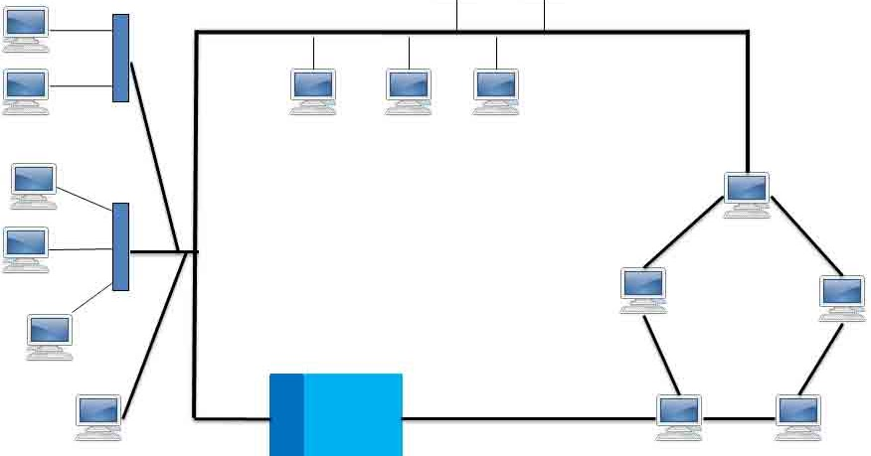

* **A hybrid topology is a type of network that uses two or more different network Topologies**
* **Advantages**
  + - It’s Reliable
    - It is Easy for scalable
    - FLEXIBLE : Hybrid network can be designed according to the requirement
* **Disadvantages**
  + - Complexity of designing
    - Costly Connecting Device are Required.

Tree Topology

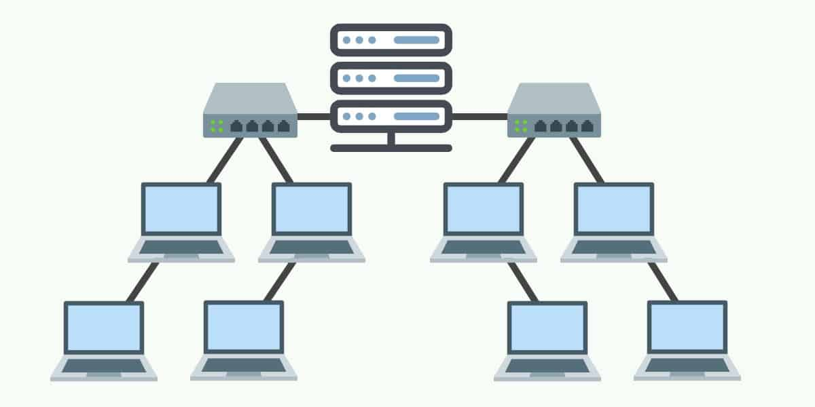

* **A tree topology is a special type of structure whare many connected elements are arranged like the branches of a tree .**
* **Advantages**
  + - It’s Flexible
    - Centralized monitoring for control
    - Easy to extending
* **Disadvantages** 
  + - If Connecting Device/Cable not working , network goes Down .

**Cellular topology**

* **In Wireless media , each point transmits in certain geographical area ,Devices that are in the cell communicate through a central Hub .Hubs in different cells are interconnected .**
* **“HANDOFF” =** In cellular Communication the handoff is the process of transferring an active cell or data session from one cell to another cell

Transmission media

# **Co-Axial**

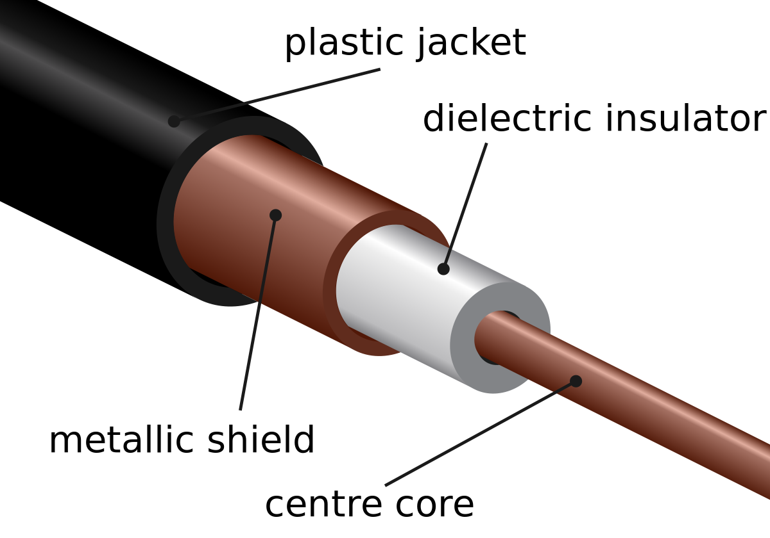

# **Twisted Pair**

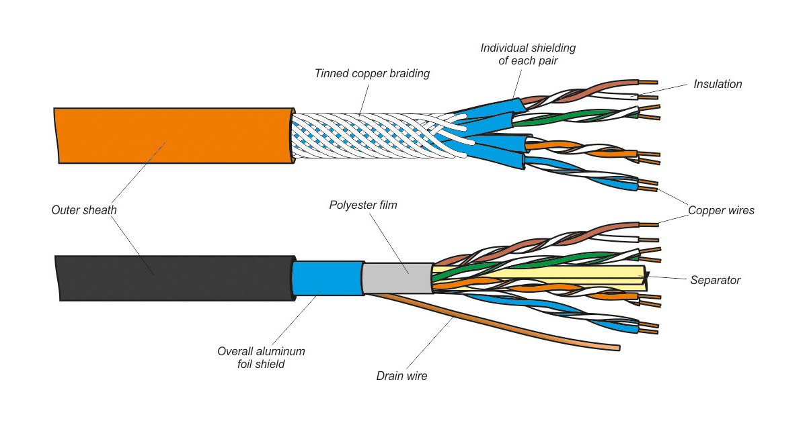

# **Fibred Optics**

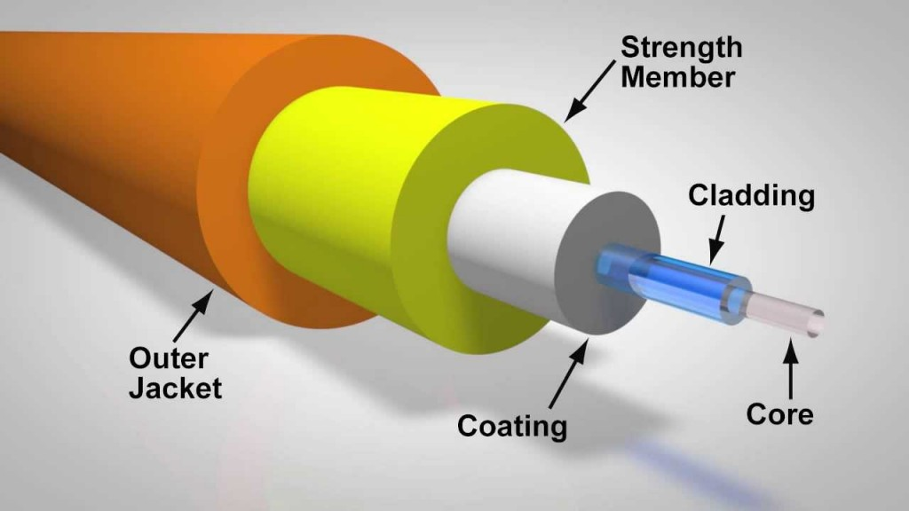

Cable crimping /Panching

* The “TIA/EIA” 586-A Standard Which was ratified in 1995 . It was replaced by the “TIA/EIA” 568-B Standard in 2002 .

# TIA = “Telecommunications Industry Association

* EIA = “Electronic Industries Association

# **Uses of Cross-Over / Straight-Through Cable**

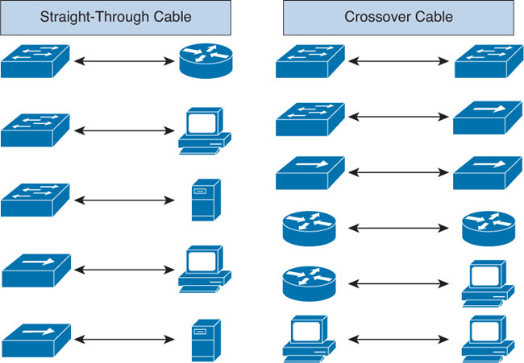

# Type of Cable

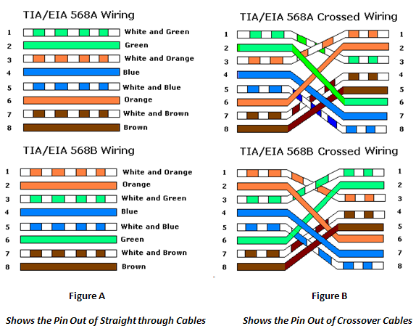

# Rule Of Cross Over Cable (1-3 & 2-6 interchanges )

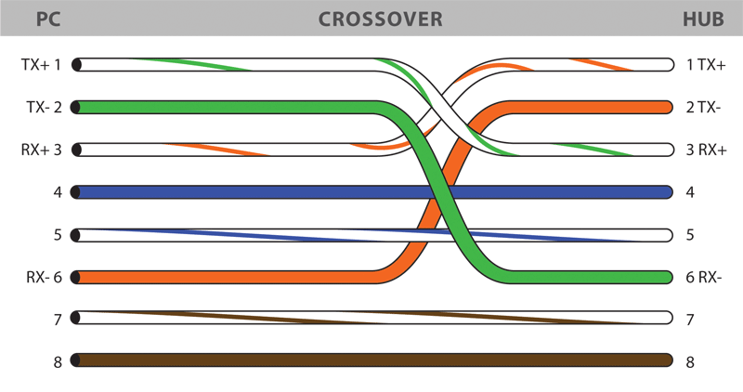

OSI Reference Model

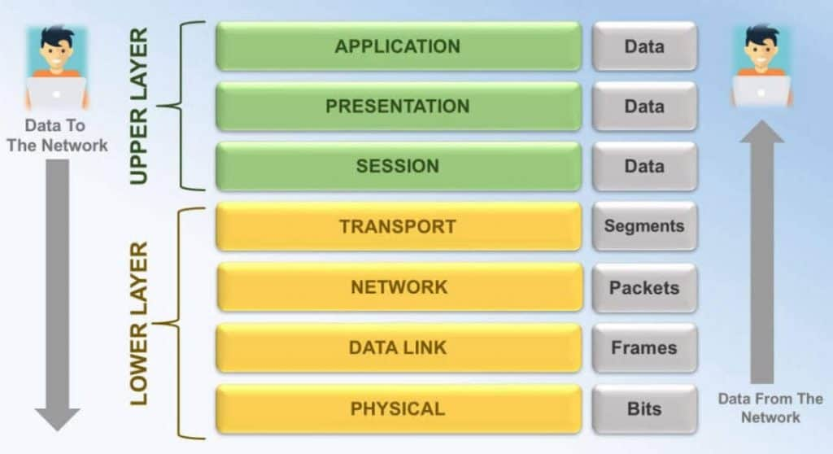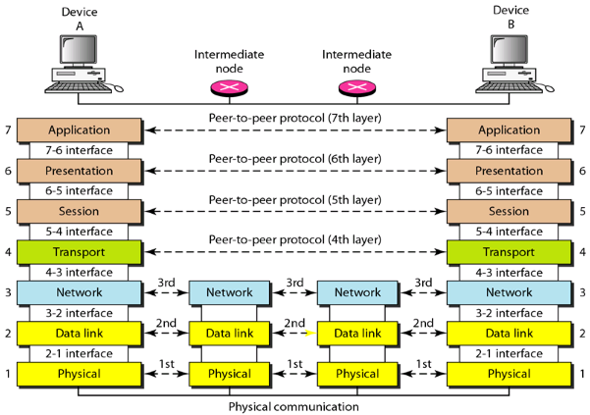

# OSI Reference Model

* The Open Systems Interconnection (OSI) model was developed by the International Organization for Standardization (ISO), and formalized in 1984. It provided the first framework governing how information should be sent across a network.

# OSI Model - The Application Layer

The Application layer (Layer-7) provides the interface between the user application and the network. A web browser and an email client are examples of user applications.

## Examples of Application layer protocols

• FTP, via an FTP client

• HTTP, via a web browser

• POP3 and SMTP, via an email client

## Functions:

• Identifies communication partners

• Determines resource availability

• Synchronizes communication

# OSI Model - The Presentation Layer

The Presentation layer (Layer-6) controls the formatting and syntax of user data for the application layer. This ensures that data from the sending application can be understood by the receiving application.

Standards have been developed for the formatting of data types, such as text, images, audio, and video. Examples of Presentation layer formats include:

• **Text** - RTF, ASCII, EBCDIC

• **Images** - GIF, JPG, TIF

• **Audio** - MIDI, MP3, WAV

• **Movies** - MPEG, AVI, MOV

## Functions:

* **Translation =** “If two devices do not support the same format or syntax, the Presentation layer can provide conversion or translation services to facilitate communication.”
* **Encryption**
* **Compression**

OSI Model - The Session Layer

The Session layer (Layer-5) is responsible for establishing, maintaining, and ultimately terminating sessions between devices. If a session is broken, this layer can attempt to recover the session

## Sessions communication falls under one of three categories:

**• Full-Duplex** – simultaneous two-way communication

**• Half-Duplex** – two-way communication, but not simultaneous

**• Simplex** – one-way communication

# OSI Model - The Transport Layer

The Transport layer (Layer-4) does not actually send data, despite its name. Instead, this layer is responsible for the reliable transfer of data, by ensuring that data arrives at its destination error-free and in order

## Transport layer communication falls under two categories:

• **Connection-oriented** – requires that a connection with specific agreed-upon parameters be established before data is sent.

• **Connectionless** – requires no connection before data is sent.

## Connection-oriented protocols provide several important services:

• **Segmentation and sequencing** – data is segmented into smaller pieces for transport. Each segment is assigned a sequence number, so that the receiving device can reassemble the data on arrival.

• **Connection establishment** – connections are established, maintained, and ultimately terminated between devices.

• **Acknowledgments** – receipt of data is confirmed through the use of acknowledgments. Otherwise, data is retransmitted, guaranteeing delivery.

• **Flow control** (or **windowing**) – data transfer rate is negotiated to prevent congestion.

## The TCP/IP protocol suite incorporates two Transport layer protocols

**• Transmission Control Protocol (TCP)** – connection-oriented

**• User Datagram Protocol (UDP)** – connectionless

# OSI Model - The Network Layer

The Network layer (Layer-3) controls internetwork communication .

## It has two key responsibilities:

• **Logical addressing** – provides a unique address that identifies both the host, and the network that host exists on.

• **Routing** – determines the best path to a particular destination network, and then routes data accordingly. Two of the most common Network layer protocols are:

• **Internet Protocol (IP)**

• Novell’s **Internetwork Packet Exchange** (IPX).

IPX is almost entirely deprecated. IP version 4 (IPv4) and IP version 6 (IPv6) are covered in nauseating detail in other guides

# OSI Model - The Data-Link Layer